Content Planner

Please compile your website content and return to us via email. Once we upload and format your content, we’ll be in touch.

A website needs to look good and it needs to read well. One of the most common mistakes a new website owner makes is to paste the marketing material from their brochures onto their website. Remember that writing for the web is very different from writing for print. Keep it simple and easy to read. If you feel overwhelmed and want help with your copywriting call us for a quote.

If you have any images or files you’d also like uploaded, please send as separate attachments in your email to us. Images should be supplied in JPEG format.

Company Details:

Business name: | Contact person:
Phone: | Email:
Website:

My Website Content

It’s time to think about the pages you want. Remember it’s best to have one type of product/service or message per page.

Website Structure Guide
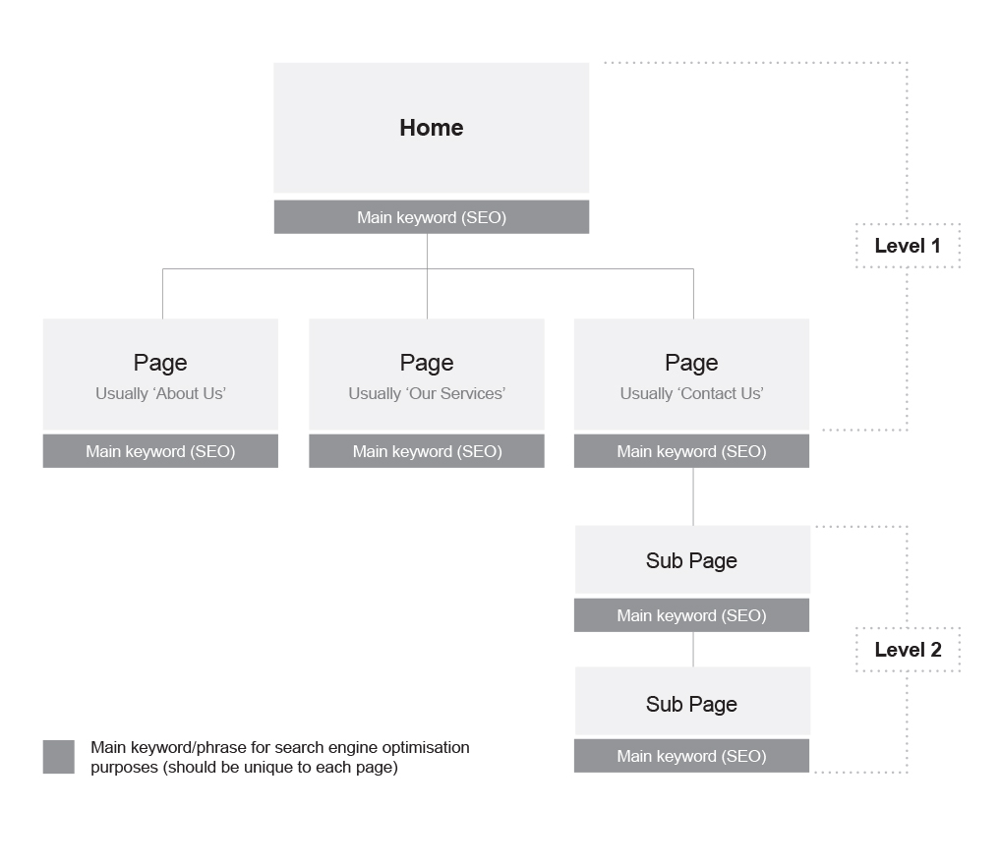

Page name:
Catchy page heading:
Keyword/Key phrase:
Including keywords in your site correctly will have a positive impact on your traffic and results.
Page content/Text:
Page images:
If you want to supply any images, please type file names here and attach images as JPEG’s when you send back your planner.
Goal of this page:
ie. to communicate, to encourage contact, to sell a product, etc.

Page name:
Catchy page heading:
Keyword/Key phrase:
Including keywords in your site correctly will have a positive impact on your traffic and results.
Page content/Text:
Page images:
If you want to supply any images, please type file names here and attach images as JPEG’s when you send back your planner.
Goal of this page:
ie. to communicate, to encourage contact, to sell a product, etc.

Page name:
Catchy page heading:
Keyword/Key phrase:
Including keywords in your site correctly will have a positive impact on your traffic and results.
Page content/Text:
Page images:
If you want to supply any images, please type file names here and attach images as JPEG’s when you send back your planner.
Goal of this page:
ie. to communicate, to encourage contact, to sell a product, etc.

Page name:
Catchy page heading:
Keyword/Key phrase:
Including keywords in your site correctly will have a positive impact on your traffic and results.
Page content/Text:
Page images:
If you want to supply any images, please type file names here and attach images as JPEG’s when you send back your planner.
Goal of this page:
ie. to communicate, to encourage contact, to sell a product, etc.

Page name:
Catchy page heading:
Keyword/Key phrase:
Including keywords in your site correctly will have a positive impact on your traffic and results.
Page content/Text:
Page images:
If you want to supply any images, please type file names here and attach images as JPEG’s when you send back your planner.
Goal of this page:
ie. to communicate, to encourage contact, to sell a product, etc.
If you require more than 5 pages, please duplicate this page in this document.

